TITLE OF ARTICLE
Times New Roman, Font Size 14 and Bold

Name of Author (Corresponding Author)
(Affiliation/University/Country/Email)

Name of other Authors
(Affiliation/University/Country/Tel/Email)
Set name of Authors and Affiliations in Italics: Font Size 12, Times New Roman
Abstract (Font size of heading 12 Bold in Capital Letters, Times New Roman)
Abstract should be between 200-500 words. Font Size 12, Times New Roman.
Abstract Abstract Abstract Abstract Abstract Abstract Abstract Abstract Abstract Abstract
Abstract Abstract Abstract Abstract Abstract Abstract Abstract Abstract Abstract Abstract

Keywords: Please include 3-7 keywords here.

Introduction (Font size of heading 12 Bold in Capital Letters, Times New Roman)
Introduction should be given in this section. Font Size 12, Times New Roman.
XXXXXXXXXXXXXXXXXXXXXXXXXXXXXXXXXXXXXXXXXXXXXXXXXXXXXXXXXXXXXXXXXXXXXXXXXXXXXXXXXXXXXXXXXXXXXXXXXXXXXXXXXXXXXXXXXXXXXXXXXXXXXXXXXXXXXXXXXXXXXXXXXXXXXXXXXXXX\
Literature Review (Font size of heading 12 Bold in Capital Letters, Times New Roman)
Literature Review should be given in this section. Font Size 12, Times New Roman.
XXXXXXXXXXXXXXXXXXXXXXXXXXXXXXXXXXXXXXXXXXXXXXXXXXXXXXXXXXXXXXXXXXXXXXXXXXXXXXXXXXXXXXXXXXXXXXXXXXXXXXXXXXXXXXXXXXXXXXXXXXXXXXXXXXXXXXXXXXXXXXXXXXXXXXXXXXXX

Methodology (Font size of heading 12 Bold in Capital Letters, Times New Roman)
Details about methodology should be given in this section. Font Size 12, Times New Roman.
XXXXXXXXXXXXXXXXXXXXXXXXXXXXXXXXXXXXXXXXXXXXXXXXXXXXXXXXXXXXXXXXXXXXXXXXXXXXXXXXXXXXXXXXXXXXXXXXXXXXXXXXXXXXXXXXXXXXXXXXXXXXXXXXXXXXXXXXXXXXXXXXXXXXXXXXXXXX

Results (Font size of heading 12 Bold in Capital Letters, Times New Roman)
In this section please present the results including tables, figures, numbers and graphs (if any). Font Size 12, Times New Roman.
XXXXXXXXXXXXXXXXXXXXXXXXXXXXXXXXXXXXXXXXXXXXXXXXXXXXXXXXXXXXXXXXXXXXXXXXXXXXXXXXXXXXXXXXXXXXXXXXXXXXXXXXXXXXXXXXXXXXXXXXXXXXXXXXXXXXXXXXXXXXXXXXXXXXXXXXXXXX

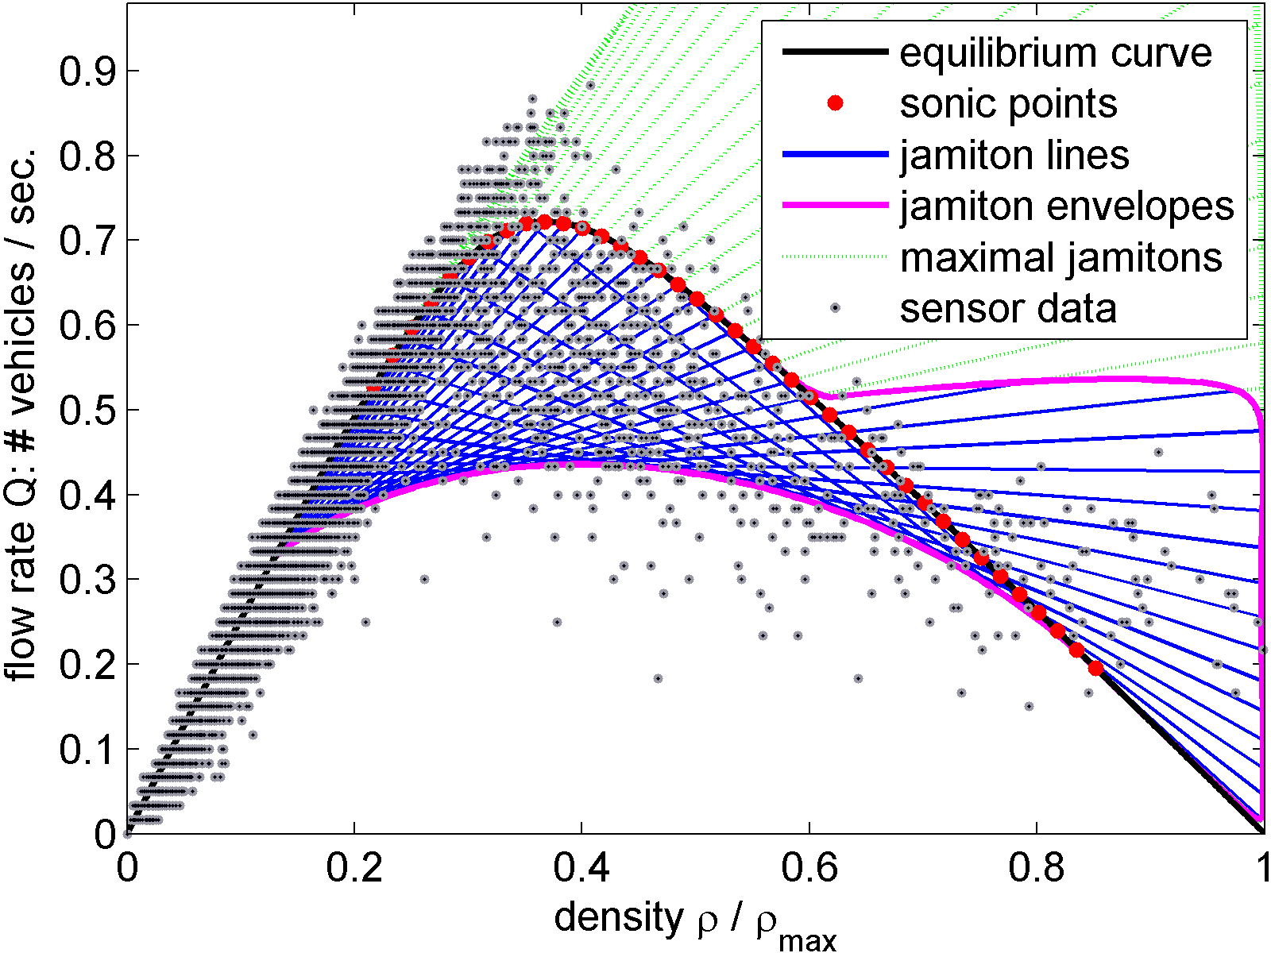

Fig.1 XXXXXXXXXXXXX font size 10

Discussion (Font size of heading 12 Bold in Capital Letters, Times New Roman)
Discussion of results/issues should be presented in this section. Font Size 12, Times New Roman.
XXXXXXXXXXXXXXXXXXXXXXXXXXXXXXXXXXXXXXXXXXXXXXXXXXXXXXXXXXXXXXXXXXXXXXXXXXXXXXXXXXXXXXXXXXXXXXXXXXXXXXXXXXXXXXXXXXXXXXXXXXXXXXXXXXXXXXXXXXXXXXXXXXXXXXXXXXXX

Table1. XXXXXXXXXX font size 10
S. No | Parameters | Values
1 | XXXXXXXX | XXXXXXXXXXXXX
2 | XXXXXX | XXXXXXXXXX
3 | XXXXXXXXXX | XXXXXXXXXXXXX

Conclusions (Font size of heading 12 Bold in Capital Letters, Times New Roman)
Conclusions of the study should be given in this section. Font Size 12, Times New Roman.
XXXXXXXXXXXXXXXXXXXXXXXXXXXXXXXXXXXXXXXXXXXXXXXXXXXXXXXXXXXXXXXXXXXXXXXXXXXXXXXXXXXXXXXXXXXXXXXXXXXXXXXXXXXXXXXXXXXXXXXXXXXXXXXXXXXXXXXXXXXXXXXXXXXXXXXXXXXX

Acknowledgements (Font size of heading 12 Bold in Capital Letters, Times New Roman)
Any acknowledgements about research funding/organizations/ persons should be given in this section. Font size 12 Bold, Times New Roman.
XXXXXXXXXXXXXXXXXXXXXXXXXXXXXXXXXXXXXXXXXXXXXXXXXXXXXXXXXXXXXXXXXXXXXXXXXXXXXXXXXXXXXXXXXXXXXXXXXXXXXXXXXXXXXXXXXXXXXXXXXXXXXXXXXXXXXXXXXXXXXXXXXXXXXXXXXXXX

References (Font size of heading 12 Bold in Capital Letters, Times New Roman)
For references please use Font Size 10, Times New Roman.

